**ChE 320_Spr_17_HW 1 Solution_*Grading Scale***

**Total: 100 pts**

(Please do not cut point more than once for the same mistake, e.g. If there are 3 parts in a question, answer was calculated wrong in the 1st part. But the method was correct for the 2nd and 3rd part, give student the points of 2nd and 3rd part*. If applicable, credits for the answers are also given for using correct units*)

1-12(10 pts). No. Selecting the three consecutive bottles and going to the production line once every hour may result in data with specific pattern and that are not random. The bottles being produced thus do not have the same chance of being selected.

*+10 for correct answer with reasonable explanation (or +5 if correct answer but unreasonable explanation)*

2-6(20 pts).

**Sample average**: *+3 for correct method, +2 for answer*

**Sample standard deviation**:*+5 for correct method, + 4for answer*



**Dot Diagram**:*+6 for correct graph*

. . . . . . . ..

-------+---------+---------+---------+---------+--------- Crack length

1.40 1.75 2.10 2.45 2.80 3.15

2-8 (30 pts). **High Dose Group:**

**Sample average:**

*+2 for correct method, +2 for answer*

**Sample variance:**

*+2 for correct method, +2 for answer*

**Sample standard deviation**:

*+2 for answer*

*+4 for correct graph*



**Control Group:**

**Sample average:**

*+2 for correct method, +2 for answer*

**Sample variance:**

*+2 for correct method, +2 for answer*

**Sample standard deviation:**

 *+2 for answer*

*+4 for correct graph*



The control group has higher variance. *+2 for correct comment*

2-38(20 pts).

1. Sample Mean: 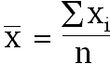 = 48.125, *+2 for answer*

Sample Median: 49*+2 for answer*

1. Sample Variance: 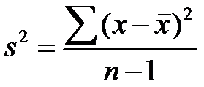=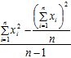7.247, *+4 for answer*

Sample Standard Deviation:  =2.692*+2 for answer*

1. The data appear to be skewed.*+4 for correct graph, +2 for comment*

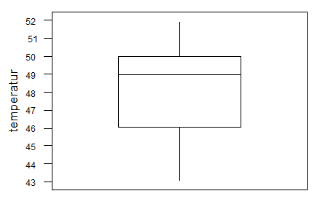

1. 5th Percentile: 43.25, *+2 for correct answer*

95th Percentile: 52*+2 for correct answer*

**2-52. (10 pts)** a) Positive sign *+2 for correct answer, +3 for correct graph*

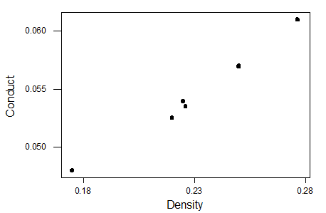

b)= 0.993. X has a strong positive correlation with Y

*+3 for correct method, +2 for correct answer*

**3.1-3.8 (3.9 not graded)(10 pts: )**

3-1. Continuous*+1.25 for answer*

3-2. Discrete*+1.25for answer*

3-3. Continuous*+1.25for answer*

3-4. Discrete*+1.25for answer*

3-5. Discrete /Continuous*+1.25for answer*

3-6. Continuous*+1.25for answer*

3-7. Discrete/Continuous*+1.25for answer*

3-8. Continuous*+1.25for answer*